Alarm: ID 53: Flexi MOC
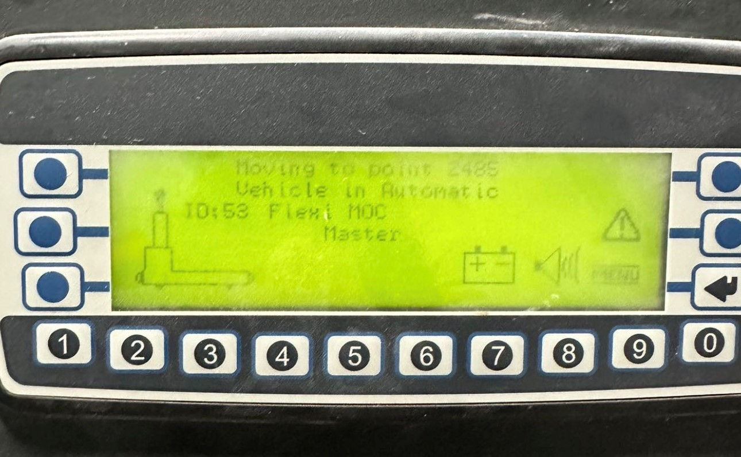
How To Fix:
To clear the alarm:
- Perform the automatic sequence:
  - Automatic Mode
  - Press the Blue button
  - Press the Green button
  - Press the Blue button again
If the issue persists, contact a qualified AGV Technician for assistance.

